COSC 412

Individual Project

Gurmilan Singh Sangha

Meeting 3/31/2021

**1.1 Project Introduction**

I am aware that the Sikh religion stands upon the principles of community and collaboration. Creating a website and an online platform for the Gurdwara could be a great way to draw in potential visitors and gain even more members of your community! In this day and age, the internet is the go-to resource for all information. The ease of typing in a few words or a phrase into a search engine and having access to thousands of websites of information is truly remarkable. By creating a website, you are able to share pictures, event details, and inform others about the Sikh religion on a massive scale as many other Gurdwaras have done. A website for the Singh Sabha of Maryland could potentially increase the number of weekly visitors, increase donations by attracting the public, and would allow easy dissemination of information. The proposed website could be named singhsabhamd.com.

**1.2 Project Deliverables**

* Individual Project Proposal
* Permission from Admin Staff (@Gurdwara)
* Design Review Mtg meeting
* List of requirements
* Use Case Diagram
* SPMP
* Proposed Design
* List of Tools
* Functioning Website
* Presentation

**1.3 Evolution of the SPMP**

* Corrections Made to the Individual Project Proposal
* Corrections might need to be made the SPMP after meeting with Professor Broadwater.

**1.4 Reference Materials**

* Slides Provided by Professor Broadwater

**1.5 Definitions and Acronyms**

**Gurdwara** - the holy temple for people in the Sikh religion and it translates to the Guru’s Door.

**SPMP**- Software Project Management Plan

**2.1 Project Organization**

I will be your sole contact in this project as I intend to take this on as an individual project. As a native Punjabi speaker, I believe this will stand a great advantage with communicating with the elders of the Gurdwara who may have contributions for the website. My role will range from the client liaison to the developer for this project. As both the manager for this project and a member of this Gurdwara, my role is a double-edged sword; I can make executive decisions for the website with the insight I have as a member and I can reach out to the leaders and other members of the Gurdwara for input in the decision-making process. The deadlines, however, will be provided by Professor Broadwater. I will be paying for the necessary resources for this project, but I will try to limit spending since I am on a budgetary constraint.

**2.2 Assumptions, Dependencies and Constraints**

An assumption that was made is that a large portion of the products like API’s Plugin and other services like hosting and purchasing the domain name will be relatively inexpensive or free. A constraint which I must disclose to you is the limited amount of money which I can use to create this website. However, a dependency of this project is you! A large part of website creation is making sure that the client is happy and uploads the appropriate information; I will depend on you, the leaders of the Gurdwara, to make sure that the information and design is appropriate and abides by religious rules.

**2.3 Risks**

This project has several large risks such as user adoption, inappropriate usage, limitation of time, and the size of project. I am worried that a large portion of the Gurdwara community might not adopt to using a different website than Facebook. I am aware that most members use Facebook and Whatsapp to communicate, but I will try to integrate Facebook links into the site for members to share. I also worry about the people finding this website and commenting or interfering with other users, but to limit this risk factor, I created a new user for the public. There is a limitation in this whole project because this ultimately has a deadline, where other websites like Facebook, Google and YouTube have gone through many iterations to test what best fits the community. The last risk factor is the size of the website, I must make sure all functions are working correctly, while I am a capable programmer this is my first time creating a website. However, I assure you that I am qualified to create this website and will try to limit the impact that these risks will have on the Gurdwara’s reputation and its community members.

**3.0 Technical**

**Tools to be Used.**

* WordPress
* GitHub
* Elementor
* Positive SSL – Provides an SSL certificate the Website
* Draw.io – used to make diagrams
* Loginizer – prevents brute force attacks on the login page
* Modern Events calendar lite –
* Smart Slider 3

**3.1 Explanation of the tools and methodology**

To assure you of my abilities, I can tell you a bit about my past experiences. I have used Name Cheap and WordPress to create a website for my neighbor. He is a therapist in the Baltimore area and has greatly benefitted from the creation of his website, but I also learned a lot from the experience. This project will be a good test of my abilities and allow me to show my skillset. I have also decided to follow the water methodology. I have created a design and am beginning to develop the website. Testing the website will be very important part of the project. Once that is developed, the project can be published in its final factor. I chose this methodology over the Agile methodology because I have a fixed time, fixed scope, fixed budget. Agile is meant for large enterprise level projects so I believe the aforementioned water methodology will be most appropriate in this situation.

**3.2 Technical User Requirements for Each User**

**Admin User**

* The admin will be the only user allowed to add calendar events.
* Will be able login and logout.
* The Admin users will be able to upload a bio with personal info.
* The Admin users will be able to upload Blog posts.
* The Admin users will be able to Read blog posts.
* The Admin users will be able to upload pictures.
* The Admin users will be able to comment on pictures.
* The Admin users will be able to view pictures.

**Verified Users**

* The Verified users will be able login and logout.
* The Verified users will be able to upload Blog posts.
* The Verified users will be able to Read blog posts.
* The Verified users will be able to upload pictures.
* The Verified users will be able to comment on pictures.
* The Verified users will be able to view pictures.
* The Verified users will be able to upload a bio with personal info.

**General Public Users**

* The General Public users will be able to view pictures.
* The General Public users will be able to read blog posts.
* The General Public users will be able to upload a bio with personal info.

**3.3 User Diagram**

Based on my previous experiences, I would strongly recommend that we move forward with a website with three different types of users. There would be the general public, verified users, and then administrative staff. The general public would have limited abilities, mainly only being able to read the site, view the pictures, and create a bio for a personal user. Verified users would have to contact the administrative staff in order to gain additional access. They would log in and gain the ability to upload blogs, pictures, comments and to request calendar events for services which they wish to claim. The administrative staff has all the aforesaid abilities, but can also remove posts, create other admin users, add calendar events, and ban users.

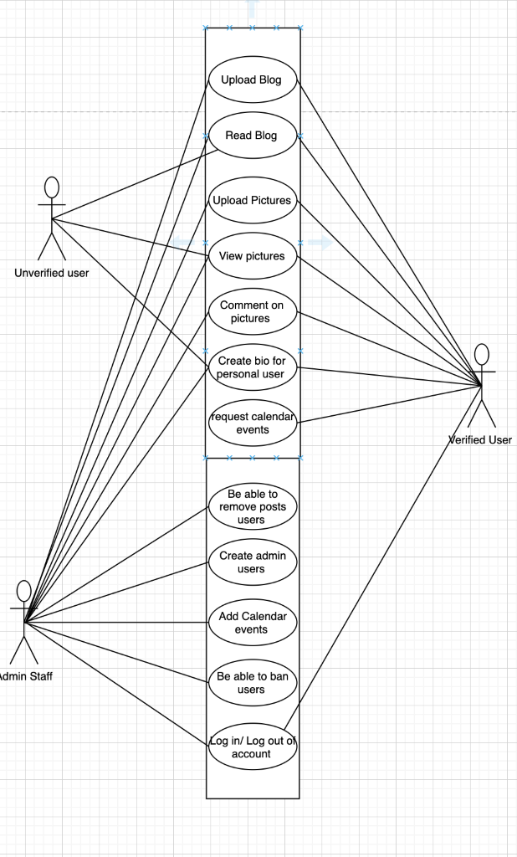

**3.4 Gantt Chart** 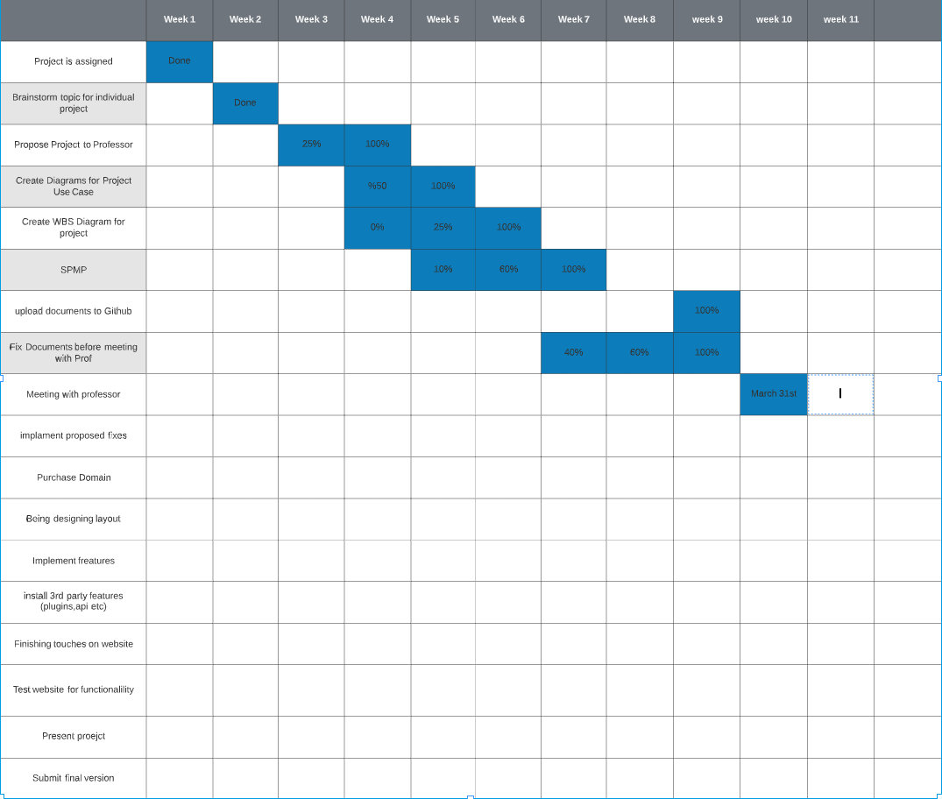

**3.5 WBS Chart**

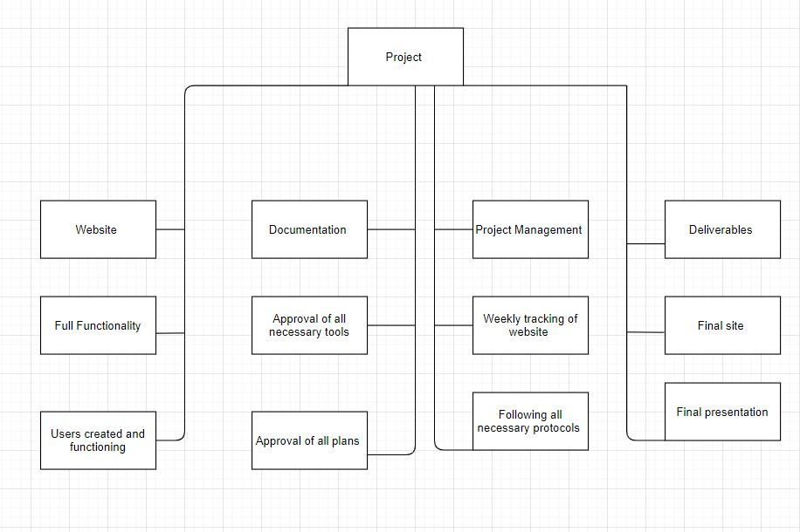

**https://github.com/Gsangha107/COSC412-Personal-Project**